Name: __________________________________ Date: ___________________
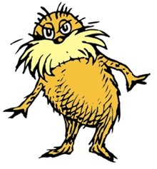

Practice: Codominance, Incomplete Dominance, and multiple alleles

- Grickle-grass can be tall (T), medium (Ts) or short (s). Cross a medium plant with a short plant. Determine the chances of having short offspring.

Which inheritance pattern does Grickle-grass display for height? _______________

- Truffula trees have multiple alles for color. They can be yellow (t), orange (Tº), purple (T^{P}) or fuchsia (T^{P}T^{O}). Purple is the most dominant, fuchsia is dominant to yellow and orange, but not purple; orange is dominant over yellow, and yellow is recessive to all.

a) Cross a yellow Truffula tree with a fuschia Truffula tree. Calculate the chance of getting:
- a yellow tree
- a fuchsia tree
- an orange tree
- a purple tree

b) Cross a purple Truffula tree that is also carrying the allele for orange with a homozygous orange tree. Determine the correct prediction for orange trees among offspring.

c) Cross a homozygous fuchsia tree with a yellow tree.
Take the offspring from the cross and do a second pair crossing one offspring with a purple tree that also carries the fuchsia allele.
List all genotypes and phenotypes as a percentage.

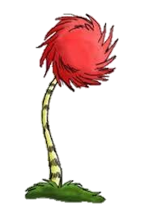

d) Though Truffula trees have multiple alleles, what other pattern of inheritance do they illustrate as well?

3) Bar-ba-loots can have curly fur (C), straight fur (S) or wavy fur (CS). Cross two Bar-ba-loots with wavy fur. Determine phenotypic and genotypic results as a percentage.

Which pattern of inheritance does fur in Bar-ba-loots demonstrate? _________________

4) Humming-Fish can 1 fin on their backs (Fº), two fins on their backs (F^{t}) or a combination of both 1 and 2 to make 3 (FºF^{t}). Cross a one-finned fish with a three-finned fish. Determine phenotypic and genotypic results as a percentage.

Which pattern of inheritance does fins in Humming Fish demonstrate? ______________

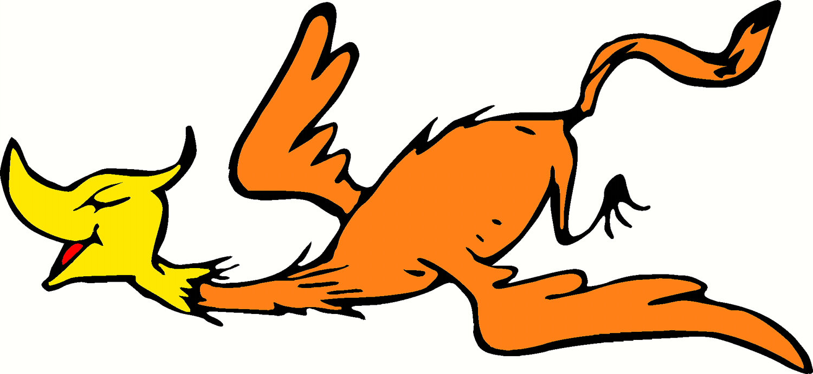
5) Swomee Swans can have black feet, yellow feet, or black feet with yellow stripes. Determine your own genotype key (letters) to represent the alleles:
black feet= _______ yellow feet= ________ black feet with yellow stripes=_________

Cross a black-footed Swomee Swan with a hybrid-footed Swomee Swan. Determine phenotypic and genotypic results as a percentage.

Which pattern of inheritance does foot color in Swomee Swans represent? ___________

6) Truffula fruits can be purple, red, or blue. Make another key to represent the alleles.

Cross two Truffula trees that have purple fruit. Determine the predicted outcome of fruit colors among the cross.

Which pattern of inheritance does the color of Truffula fruits demonstrate? ___________________

