Name: __________________________________ Date: ___________________
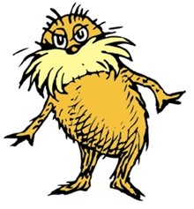

- Grickle-grass can be tall (T), medium (Ts) or short (s). Cross a medium plant with a short plant. Determine the chances of having short offspring.

Which inheritance pattern does Grickle-grass display for height? _______________

- Truffula trees have multiple alleles for color. They can be yellow (t), orange (Tº), or purple (T^{P}). However, there is also a fourth color: fuchsia (T^{P}T^{O}), which forms from incomplete dominance among purple and orange alleles. Yellow is the most recessive, orange and purple are incompletely dominant.

a) Cross a yellow Truffula tree with a fuschia Truffula tree. Calculate the chance of getting:
- a yellow tree
- a fuchsia tree
- an orange tree
- a purple tree

b) Cross a yellow Truffula tree that is also carrying the allele for orange with a heterozygous orange tree. Determine the correct prediction for yellow trees among offspring.

c) Cross a fuchsia tree with a homozygous orange tree.
List all genotypes and phenotypes as a percentage.

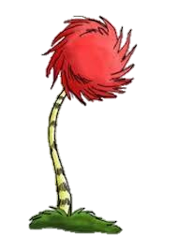

d) Why do Truffula tree genetics exhibit BOTH multiple alleles AND incomplete dominance?

3) Bar-ba-loots can have curly fur (C), straight fur (S) or wavy fur (CS). Cross two Bar-ba-loots with wavy fur. Determine phenotypic and genotypic results as a percentage.

Which pattern of inheritance does fur in Bar-ba-loots demonstrate? _________________

4) Humming-Fish can 1 fin on their backs (Fº), two fins on their backs (F^{t}) or a combination of both 1 and 2 to make 3 (FºF^{t}). Cross a one-finned fish with a three-finned fish. Determine phenotypic and genotypic results as a percentage.

Which pattern of inheritance does fins in Humming Fish demonstrate? ______________

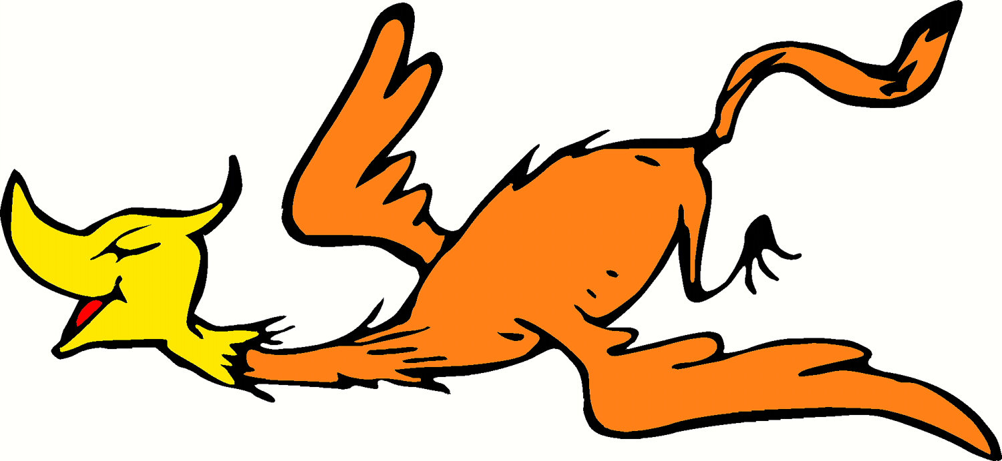
5) Swomee Swans can have black feet, yellow feet, or black feet with yellow stripes. Determine your own genotype key (letters) to represent the alleles:
black feet= _______ yellow feet= ________ black feet with yellow stripes=_________

Cross a black-footed Swomee Swan with a hybrid-footed Swomee Swan. Determine phenotypic and genotypic results as a percentage.

Which pattern of inheritance does foot color in Swomee Swans represent? ___________

6) Truffula fruits can be purple, red, or blue. Make another key to represent the alleles.

Cross two Truffula trees that have purple fruit. Determine the predicted outcome of fruit colors among the cross.

Which pattern of inheritance does the color of Truffula fruits demonstrate? ___________________

